
HOSPITALITY RIDER

Note: This rider agreement has been prepared to ensure that Desmond Day presents the "best performance possible". All items will be used and consumed responsibly. We understand that every show is different based on budget. Please contact us if any portion of this rider is to be omitted. Thank you.

ACCOMMODATIONS
- 1 Room of the Holiday Inn quality or Air BnB
- The buyer agrees to supply the above at no cost to Desmond Day
- The buyer agrees to provide a cash buyout equivalent to the cost of the rooms if requested Some preferred accommodations include the following (in no specific order):
- SHERATON HOTELS (preferred choice), SHERATON 4 POINTS, MARRIOTT, DELTA HOTELS,
- ALOFT, WESTIN, ELEMENT, RADISSON, HOLIDAY INN, SANDMAN SIGNATURE
- IF AT ALL POSSIBLE HOTEL IS TO BE NO MORE THAN 0.5 MILES FROM VENUE, UNLESS APPROVED

DRESSING ROOMS
Requests 1 clean private dressing room with facilities and will include:
- Clean white towel
- Ample A.C. Outlets
- Hi-speed wireless internet
- 1 Garbage Can
- 4 AA Batteries (Requested but not necessary)

FOOD & BEVERAGE
- A hot meal or $30 buyout with 4 bottles of water
- A selection of tea
- Hot Water or access to a kettle to boil water
- Fruit, veggie and/or meat tray (Requested but not necessary)

Thank you in advance! If you have any questions please feel free to contact Parsons Music Management.
Email: parsonsmusicmgmt@gmail.com
Phone: (250) 702-5778
or Desmond Day directly
Email: desmonddaymusic@gmail.com
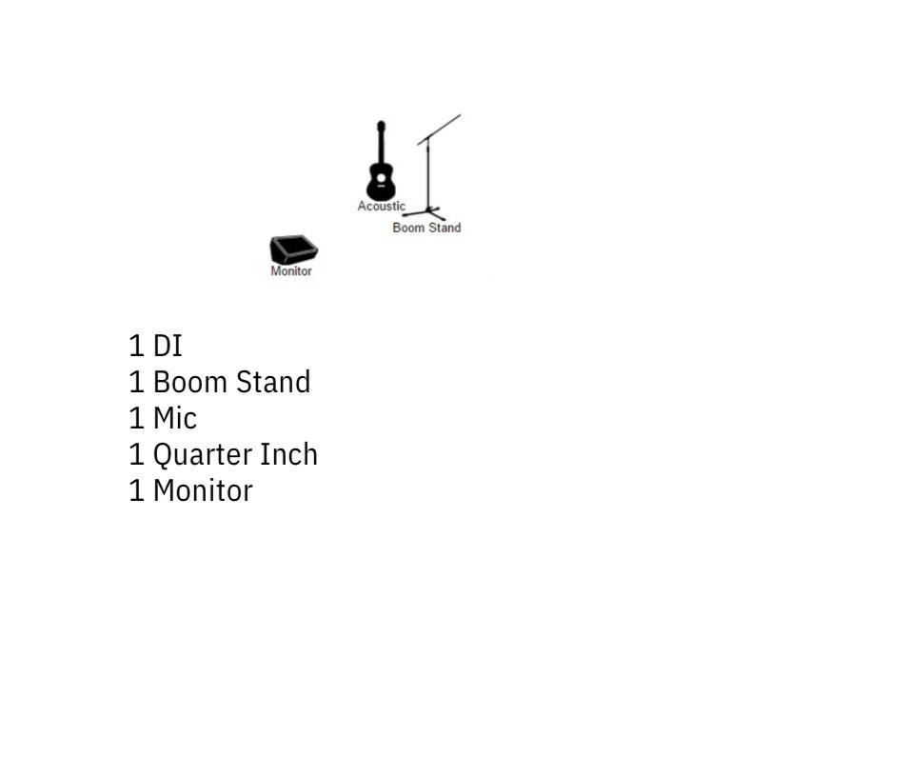
PA REQUIREMENTS
- We suggest that a 12 inch subwoofer or larger be included with the sound system on site. Please contact us if any portion of the tech rider will be omitted.

ACOUSTIC RIDER
(Includes a tall stool for sitting)

